# Introduction to the e-census Handbook

## Background

Population and housing censuses (PHC) provide countries with fundamental demographic and socio-economic information. This information is key for planning, programming, and monitoring international, regional, and national commitments like the global 2030 Agenda for Sustainable Development, Africa Agenda 2063, and various national development framework targets.

Population and housing censuses provide a wide range of demographic indicators that allow for disaggregation by small geographic areas and small population groups. At small geographic areas or sub-populations, the population census may be the only source of information for certain social, demographic, and economic characteristics. Population and housing censuses are one of the most complex and costly statistical operations due to the involvement of a huge number of field workers, requiring a long time for preparation and post-enumeration activities.

In the 2020 Round of population and housing censuses, all African countries committed to conduct a ‘digital’ population and housing census. This was in line with the recommendations of the 7th Statistical Commission for a transition from manual to digital systems and the use of improved methods and new technologies in implementation of a PHC in Africa. In fact, against a back-drop of the covid-19 pandemic, civil unrest and reduced budgets, only 39 of the 54 African member states carried out a census in the 2020 round.

With further strain on budgets in the 2030 round, the increased use of technology aimed at improving quality which reducing costs is even more important. There have been continuous efforts to use alternative approaches and technologies to improve on data quality, timeliness and dissemination of census results while considering the ever-increasing costs of carrying out population censuses. This has resulted in undertaking of digital censuses in which mobile technology and the internet is used to capture and transmit data to central servers. Advances in information and communication technology across the globe has changed how routine statistical business processes, such as creation of enumeration areas (EAs), data capture and validation, data processing, and data dissemination, are being carried out.

During implementation of the 2020 round of digital PHCs, various experiences were acquired, and lessons learnt that could inform countries planning for a digital PHC and preparation for the 2030 Round of PHC in Africa. Sharing experiences and good practice from the use of technology during the 2020 round of censuses will be crucial to informing the 2030 round of PHCs in Africa. Each country that implemented, or planned to implement, a digital census in the previous round, has had a unique experience and learned lessons within the context of Africa that are worth documenting for future planning and implementation of PHCs.

At the 8th session of the Statistical Commission for Africa, ECA and its partners were encouraged to continue embracing South-South cooperation and other approaches of sharing technical expertise among countries in implementation of censuses; Member States were called upon to share experiences and key lessons learned from the 2020 round of census and work with ECA and other partners to build a collective knowledge base for all African countries that can be used as a resource during the 2030 round. The commission also called upon ECA, UNFPA and other development partners to continue providing support to countries in the implementation of the 2020 round of censuses and in preparation for the 2030 round, as well as, to coordinate technical assistance to countries for efficient implementation.

It is against this background that a e-census handbook has been developed to serve as a reference document for African countries in undertaking digital censuses. This e-census handbook complements the suite of UN guidance documents on censuses, but principally the [UN Principles and Recommendations (P&R) for Population and Housing Censuses (Revision 4),](https://unstats.un.org/unsd/demographic-social/meetings/2024/egm-20240904/p&r-rev4-draft-20240809.pdf) the [Guidelines on the use of electronic data collection technologies in population and housing censuses](https://unstats.un.org/unsd/demographic/standmeth/handbooks/guideline-edct-census-v1.pdf), the [Handbook on geographic information systems and digital mapping](https://unstats.un.org/unsd/publication/seriesf/seriesf_79e.pdf), and the [Handbook on the Management of Population and Housing Censuses](https://unstats.un.org/unsd/publication/seriesf/series_f83rev2en.pdf) among others.

## Purpose

The e-census handbook provides a repository of experiences, key lessons learned and good practices in planning and implementation of digital censuses in Africa during the 2020 Round of Population and Housing Censuses. It enables NSOs and other partners to have exposure to experiences from across Africa and apply these to their own census planning and design context.

More specifically, the e-census handbook:

1. Presents the experiences and lessons learnt in implementation of preparatory activities for a digital PHC in Africa.
2. Provides experiences in acquiring and using electronic devices in digital PHC undertaking.
3. Gives the key lessons, issues and how the use of electronic devices and other technologies (e.g., e-recruitment) impacts on the census business process model.
4. Highlights areas of country expertise that could potentially be called upon in future to provide technical assistance to African countries as part of their census development.
5. Informs planning for the 2030 African Round of PHC through the identification of key areas where work at the regional level is required to support the planning and implementation of censuses.

## Rationale

The e-census handbook draws its content from experiences of National Statistical Offices (NSO), Pan-African Agencies and census experts supporting implementation of PHC in Africa during the 2020 Round of PHC. The information is provided voluntarily by the various stakeholders, reviewed, and published in the handbook for reference especially with the countries planning to undertake a PHC and informing planning for the 2030 Round of PHC in Africa. It is a ‘living’ document – it will grow to accommodate new experiences, as more NSOs undertake and evaluate their own digital censuses.

## Target Audience

This handbook targets census officials supporting implementation of digital population and housing censuses in Africa. These include census officials within NSOs, Pan-African agencies and other institutions supporting implementation of PHCs in Africa.

## Structure

This e-census handbook has chapters structured along the Census business model including a checklist to guide the planning process. The full list of the chapters is as indicated below.

1. Project Planning and Management
2. Geospatial Mapping and EA Database Management
3. Enumeration Instruments, Applications and Tools
4. Data Capture, Transmission and Management
5. Census Testing and Pilots
6. Recruitment and Training of Field Personnel
7. Deployment and Supervision of Field Personnel
8. Enumeration and Logistics
9. Quality Assurance, Monitoring, Evaluation and Risk Management
10. Census Analysis, Products, Dissemination and Archiving
11. Partnerships and Collaboration
12. Advocacy, Publicity and Resource Mobilization
13. Procurement and Financial Management
14. Post-Enumeration Survey
15. Alternative Approaches
16. Checklist for Planning a Digital Population and Housing Census

You can easily navigate to any chapter by clicking on Experiences and Lessons in the bar at the top of the page, and then clicking on any chapter in the menu on the left-hand side of the page. Each chapter includes a summary of the relevant case studies, you can also find the full text of the case studies by clicking on the link within the chapter or clicking on Case Studies in the bar at the top of the page. Recommendations are included in each chapter, but can also be found in a separate section, again this can be easily found by clicking on the relevant link in the bar at the top of the page. The planning checklist can also be easily accessed by clicking on the Checklist link.

Also found in the bar at the top of the page is a search bar, type a word or phrase here and you will be presented with a list of all the places in the E-Handbook where that occurs.

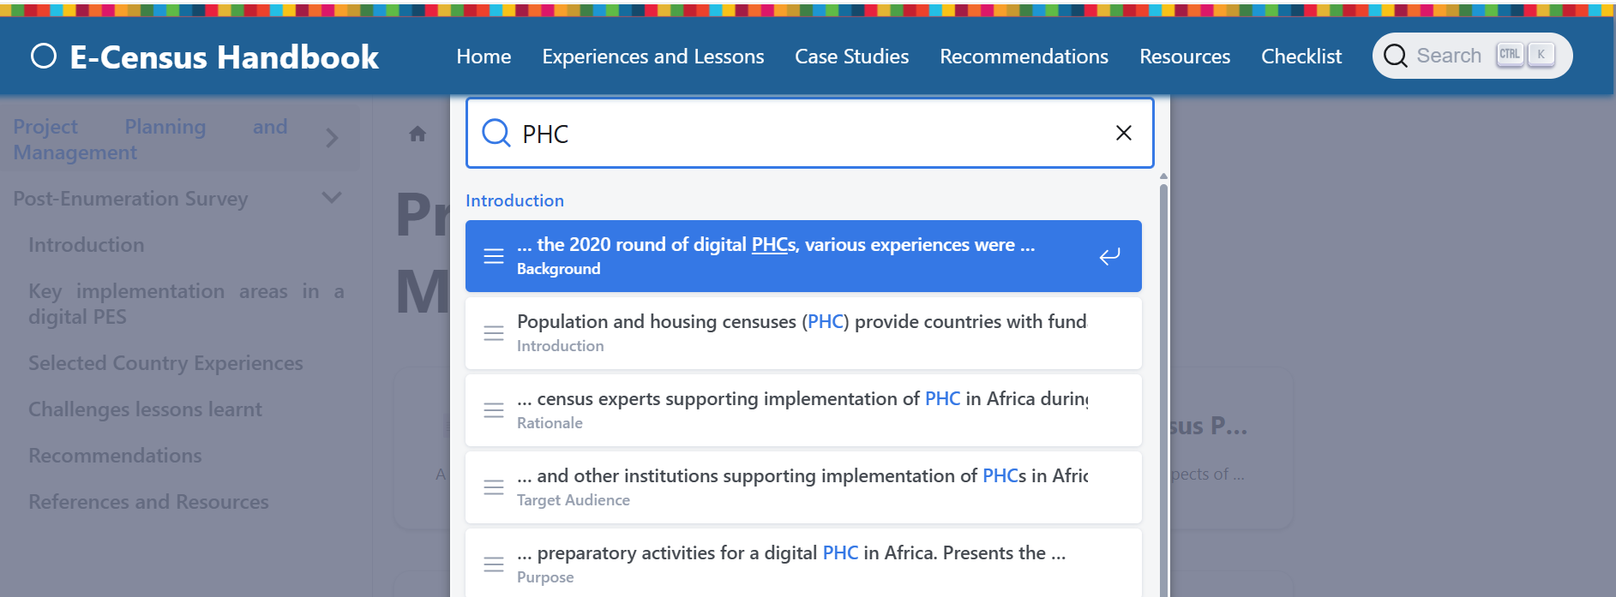

Clicking on the chat icon  in the bottom right corner of the page will open a chatbot that you can interrogate about the e-census handbook.

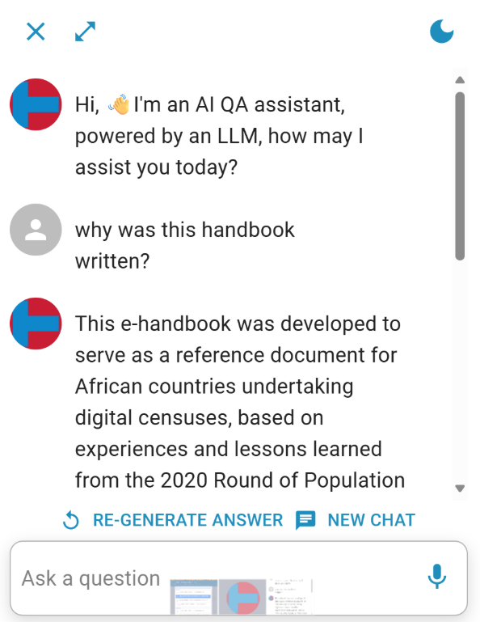

## References

1. UN Principles and Recommendations for population and housing Census. Revision 4. https://unstats.un.org/UNSDWebsite/statcom/session_56/documents/BG-3b-Draft_P&R_4th_Rev-E.pdf
2. Guidelines on the use of electronic data collection technologies in population and housing censuses.<https://unstats.un.org/unsd/demographic/standmeth/handbooks/guideline-edct-census-v1.pdf>
3. [Handbook on geographic information systems and digital mapping](https://unstats.un.org/unsd/publication/seriesf/seriesf_79e.pdf) <https://unstats.un.org/unsd/publication/seriesf/seriesf_79e.pdf>
4. [Handbook on the Management of Population and Housing Censuses](https://unstats.un.org/unsd/publication/seriesf/series_f83rev2en.pdf) https://unstats.un.org/unsd/publication/seriesf/series_f83rev2en.pdf